Practical No.1B
Create a web application to find addition of a three number using Simple SOAP service
Server Side

Server-Side Code:-
package Server;
import javax.jws.WebService;
import javax.jws.WebMethod;
import javax.jws.WebParam;
@WebService(serviceName = "AdditionWS")
public class AdditionWS {
@WebMethod(operationName = "Addition")
public double Addition(@WebParam(name = "n1") double n1, @WebParam(name = "n2") double n2, @WebParam(name = "n3") double n3) {
//TODO write your implementation code here:
return (n1+n2+n3);
} }
Server-Side Output:-

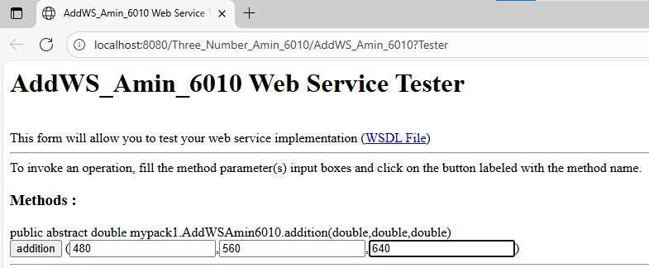
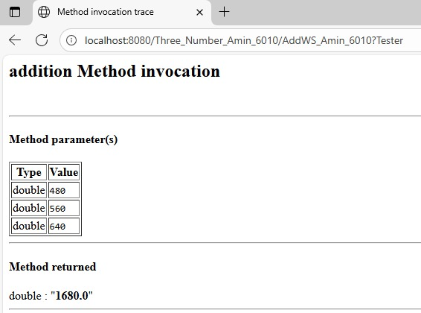

Client-Side Code:-
input.jsp:-
<%@page contentType="text/html" pageEncoding="UTF-8"%>
<!DOCTYPE html>
<html>
<head>
<meta http-equiv="Content-Type" content="text/html; charset=UTF-8">
<title>JSP Page</title>
</head>
<body>
<h1>Mustafa Shaikh 6082</h1>
<form action="output.jsp" method="POST">
Enter First Number : <input type="text" name="t1" value="" />
<br><br>

Enter Second Number : <input type="text" name="t2" value="" />
<br><br>

Enter Third Number : <input type="text" name="t3" value="" />
<br><br>
<input type="submit" value="Addition" />

</form>
</body>
</html>

output.jsp:-
<%@page contentType="text/html" pageEncoding="UTF-8"%>
<!DOCTYPE html>
<html>
<head>
<meta http-equiv="Content-Type" content="text/html; charset=UTF-8">
<title>JSP Page</title>
</head>
<body>
<h1>Mustafa Shaikh 6082</h1>

<%-- start web service invocation --%><hr/>
<%
try {
Client.AdditionWS_Service service = new Client.AdditionWS_Service();
Client.AdditionWS port = service.getAdditionWSPort();
// TODO initialize WS operation arguments here
double n1 = Double.parseDouble(request.getParameter("t1"));
double n2 = Double.parseDouble(request.getParameter("t2"));
double n3 = Double.parseDouble(request.getParameter("t3"));
// TODO process result here
double result = port.addition(n1, n2, n3);
out.println("Addition of THREE Numbers = "+result);
} catch (Exception ex) {
// TODO handle custom exceptions here
}
%>
<%-- end web service invocation --%><hr/>

</body>
</html>

Client-Side Output:-
